QUES 01:
#include <iostream>
#include <string>
using namespace std;

int N, targetSum;
string targetCode;
string code = "";

bool used[10] = {false};
bool found = false;
bool anyValid = false;

void generate(int position, int sum);
void tryDigit(int digit, int position, int sum);

void tryDigit(int digit, int position, int sum)
{

if (digit > 9)
{
return;
}

if (!(position == 0 && digit == 0) && !used[digit])
{
used[digit] = true;
code = code + char('0' + digit);

generate(position + 1, sum + digit);

code.pop_back();
used[digit] = false;
}

tryDigit(digit + 1, position, sum);
}

void generate(int position, int sum)
{

if (position == N)
{
if (sum == targetSum)
{
cout << code << endl;
anyValid = true;

if (code == targetCode)
{
found = true;
}
}

return;
}

tryDigit(0, position, sum);
}

int main()
{
cout << "Enter number of positions: ";
cin >> N;

if (N < 1 || N > 10)
{
cout << "N must be between 1 and 10." << endl;
return 0;
}

cout << "Enter target sum: ";
cin >> targetSum;

cout << "Enter target code: ";
cin >> targetCode;

cout << "\nValid lock codes:\n";

generate(0, 0);

if (!anyValid)
{
cout << "No valid codes found." << endl;
}

if (found)
{
cout << "Target code is among the valid codes." << endl;
}
else
{
cout << "Target code is NOT among the valid codes." << endl;
}

return 0;
}

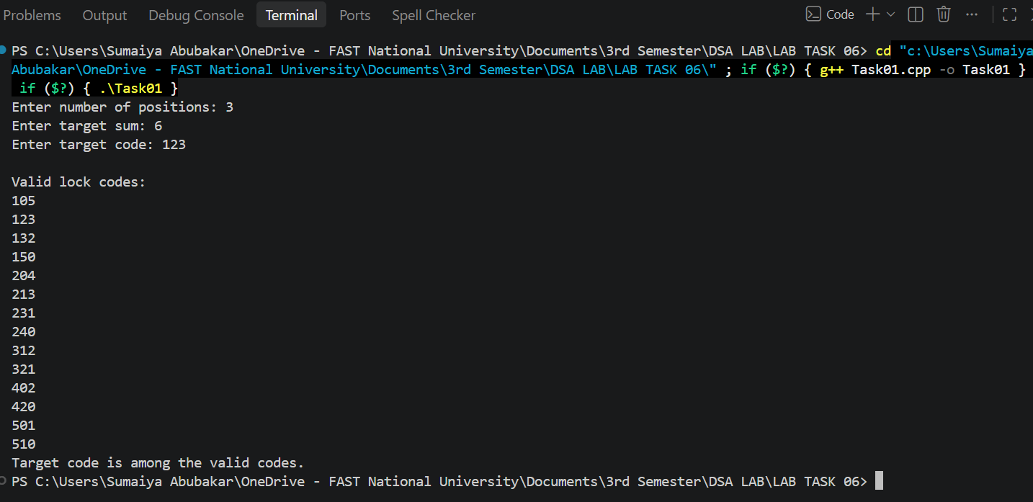

QUES 02:
#include <iostream>
using namespace std;

struct Runner
{
int stamina;
int speed;
};

bool canFollow(Runner curr, Runner next)
{
return curr.stamina + curr.speed >= next.stamina;
}

void generateOrders(Runner runners[], int n, int order[], bool used[], int pos, double avg)
{
if (pos == n)
{
cout << "Running order: ";

for (int i = 0; i < n; i++)
{
cout << "R" << order[i] + 1 << " ";
}

cout << endl;
return;
}

for (int i = 0; i < n; i++)
{
if (used[i] == true)
{
continue;
}

if (pos > 0)
{
int prev = order[pos - 1];
if (!canFollow(runners[prev], runners[i]))
{
continue;
}

if(canFollow(runners[i],runners[prev]))
{
continue;
}
}

if (pos >= n - 2 && runners[i].stamina < avg)
{
continue;
}
order[pos] = i;
used[i] = true;

generateOrders(runners, n, order, used, pos + 1, avg);

used[i] = false;
}
}

int main()
{
int n = 4;

Runner runners[4] =
{
{10, 5},
{13, 8},
{7, 4},
{15, 6}};

int order[4];
bool used[4] = {false};

int totalStamina = 0;

for (int i = 0; i < n; i++)
{
totalStamina += runners[i].stamina;
}

double avg = (double)totalStamina / n;

cout << "Average stamina: " << avg << endl;

generateOrders(runners, n, order, used, 0, avg);

return 0;
}
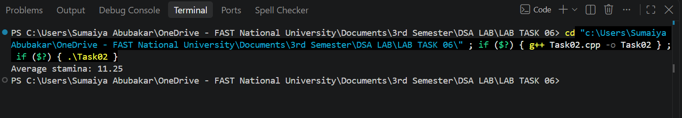

QUES 03:
#include <iostream>
#include <string>
using namespace std;

struct Student
{
string name;
string category;
int priority;
int minTokens;
int maxTokens;
int allocated;
};

bool checkStudentRestriction(Student students[]);
bool AllocateTokens(Student students[], int n, int index, int threshold, int totalTokens);
bool checkPriorityTotal(Student students[], int n, int threshold);
bool CheckMinMax(Student students[], int n);
bool CheckTokenSupply(Student students[], int n, int totalTokens);
void displayCategoryTotals(Student students[], int n);
bool checkCategoryLimit(Student students[], int n);

bool checkStudentRestriction(Student students[])
{
return students[0].allocated > students[1].allocated;
}

bool AllocateTokens(Student students[], int n, int index, int threshold, int totalTokens)
{
if (index == n)
{
return checkPriorityTotal(students, n, threshold) && CheckMinMax(students, n) && CheckTokenSupply(students, n, totalTokens) && checkCategoryLimit(students, n) && checkStudentRestriction(students);
}

for (int t = students[index].minTokens; t <= students[index].maxTokens; t++)
{
students[index].allocated = t;

bool valid = true;

for (int j = 0; j < index; j++)
{
if (students[j].category == students[index].category && students[j].allocated == t)
{
valid = false;
break;
}

if (students[j].priority == 1 && students[index].priority == 0 && students[j].allocated < t)
{
valid = false;
break;
}

if (students[j].priority == 0 && students[index].priority == 1 && students[j].allocated > t)
{
valid = false;
break;
}
}

if (valid)
{
if (AllocateTokens(students, n, index + 1, threshold, totalTokens))
{
return true;
}
}

students[index].allocated = 0;
}

return false;
}

bool checkPriorityTotal(Student students[], int n, int threshold)
{
int hightotal = 0;
int lowtotal = 0;

for (int i = 0; i < n; i++)
{
if (students[i].priority == 1)
{
hightotal = hightotal + students[i].allocated;
}
else
{
lowtotal = lowtotal + students[i].allocated;
}
}

return hightotal - lowtotal >= threshold;
}

bool CheckMinMax(Student students[], int n)
{
bool minFound=false;
bool maxFound=false;

for(int i=0;i<n;i++)
{
if(students[i].allocated==students[i].minTokens)
{
minFound=true;
}

if(students[i].allocated==students[i].maxTokens)
{
maxFound=true;
}
}

return maxFound && minFound;
}

bool CheckTokenSupply(Student students[], int n, int totalTokens)
{
int totalAllocated=0;

for(int i=0;i<n;i++)
{
totalAllocated=totalAllocated+students[i].allocated;
}

return totalAllocated<=totalTokens;
}

void displayCategoryTotals(Student students[], int n)
{
int breakfast = 0;
int lunch = 0;
int dinner = 0;

for (int i = 0; i < n; i++)
{
if (students[i].category == "Breakfast")
{
breakfast += students[i].allocated;
}
else if (students[i].category == "Lunch")
{
lunch += students[i].allocated;
}
else if (students[i].category == "Dinner")
{
dinner += students[i].allocated;
}
}

cout << "Breakfast total: " << breakfast << endl;
cout << "Lunch total: " << lunch << endl;
cout << "Dinner total: " << dinner << endl;
}

bool checkCategoryLimit(Student students[], int n)
{
int breakfast = 0;

for (int i = 0; i < n; i++)
{
if (students[i].category == "Breakfast")
{
breakfast += students[i].allocated;
}
}

return breakfast <= 5;
}

int main()
{
const int n = 4;

Student students[n] =
{
{"S1", "Breakfast", 1, 2, 5, 0},
{"S2", "Breakfast", 0, 1, 4, 0},
{"S3", "Lunch", 1, 2, 5, 0},
{"S4", "Dinner", 0, 1, 3, 0}
};

int threshold = 2;
int totalTokens = 10;

// Find the maximum possible allocation
int maxPossible = 0;

for (int i = 0; i < n; i++)
{
maxPossible += students[i].maxTokens;
}

int maxEmergency = maxPossible - totalTokens;

if (maxEmergency < 0)
{
maxEmergency = 0;
}

// Try emergency amounts from smallest to largest
bool found = false;
int emergencyUsed = 0;

for (int e = 0; e <= maxEmergency; e++)
{
if (AllocateTokens(students, n, 0,
threshold, totalTokens + e))
{
found = true;
emergencyUsed = e;
break;
}
}

// Display the result
if (found)
{
cout << "\nValid allocation found!" << endl;

cout << "\nStudent Allocations:" << endl;

int totalAllocated = 0;

for (int i = 0; i < n; i++)
{
cout << students[i].name << " ("
<< students[i].category << "): "
<< students[i].allocated
<< " tokens" << endl;

totalAllocated += students[i].allocated;
}

cout << "\nCategory Totals:" << endl;
displayCategoryTotals(students, n);

cout << "\nEmergency tokens used: "
<< emergencyUsed << endl;

cout << "Unused tokens: "
<< totalTokens + emergencyUsed - totalAllocated
<< endl;
}
else
{
cout << "No valid allocation found!" << endl;
}

return 0;
}
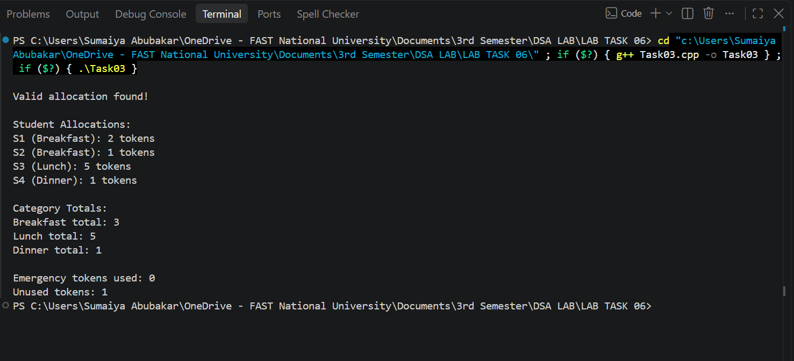

QUES 04:
#include <iostream>
using namespace std;

const int rows = 4;
const int cols = 4;

int people[rows][cols] = {
{8, 12, -1, 6},
{5, 10, 7, -1},
{-1, 9, 15, 4},
{6, -1, 8, 11}};

int units[rows][cols] = {
{2, 3, -1, 2},
{1, 3, 2, -1},
{-1, 2, 4, 1},
{2, -1, 2, 3}};

bool highRisk[rows][cols] = {
{1, 0, 0, 0},
{0, 0, 1, 0},
{0, 1, 0, 0},
{0, 0, 0, 1}};

int capacity;
int unitsUsed = 0;
int totalPeople = 0;
int bestPeople = 0;
int bestunits = 0;
int highRiskCount = 0;
bool foundSolution = false;

bool selected[rows][cols] = {false};
bool bestSelected[rows][cols] = {false};

bool checkRows()
{
for (int i = 0; i < rows; i++)
{
bool hasPeople = false;
bool hasSelection = false;

for (int j = 0; j < cols; j++)
{
if (people[i][j] != -1)
{
hasPeople = true;
}

if (selected[i][j] == true)
{
hasSelection = true;
}
}

if (hasPeople && !hasSelection)
{
return false;
}
}

return true;
}
void backtrack(int idx)
{
if (idx == rows * cols)
{
if (checkRows() && (!foundSolution || totalPeople > bestPeople))
{
foundSolution = true;
bestPeople = totalPeople;
bestunits = unitsUsed;

for (int i = 0; i < rows; i++)
{
for (int j = 0; j < cols; j++)
{
bestSelected[i][j] = selected[i][j];
}
}
}
return;
}

int row = idx / cols;
int col = idx % cols;

if (people[row][col] == -1)
{
backtrack(idx + 1);
return;
}

int extraUnit = 0;

if (highRisk[row][col] == 1 && highRiskCount == 1)
{
extraUnit = 1;
}

if (unitsUsed + units[row][col] + extraUnit <= capacity)
{
selected[row][col] = true;
unitsUsed = unitsUsed + units[row][col] + extraUnit;
totalPeople = totalPeople + people[row][col];

if (highRisk[row][col] == 1)
{
highRiskCount++;
}

backtrack(idx + 1);

selected[row][col] = false;
unitsUsed = unitsUsed - units[row][col] - extraUnit;
totalPeople = totalPeople - people[row][col];

if (highRisk[row][col] == 1)
{
highRiskCount--;
}
}

backtrack(idx + 1);
}
int main()
{
cout << "\bPeople matrix: ";
for (int i = 0; i < rows; i++)
{
for (int j = 0; j < cols; j++)
{
cout << people[i][j] << " ";
}

cout << endl;
}

cout << "\nRescue units matrix: ";
for (int i = 0; i < rows; i++)
{
for (int j = 0; j < cols; j++)
{
cout << units[i][j] << " ";
}

cout << endl;
}

cout << "\nEnter rescue unit capacity: ";
cin >> capacity;

// ADDITION 2: Start backtracking from the first cell
backtrack(0);

if (!foundSolution)
{
cout << "\nNo valid allocation exists." << endl;
}
else
{
cout << "\nSelected areas (row, column): ";

for (int i = 0; i < rows; i++)
{
for (int j = 0; j < cols; j++)
{
if (bestSelected[i][j] == true)
{
cout << "(" << i + 1 << ", " << j + 1 << ") ";
}
}
}

cout << "\nTotal people rescued: " << bestPeople;
cout << "\nTotal rescue units used: " << bestunits;
cout << "\nRemaining rescue units: " << capacity - bestunits;
}

return 0;
}
